**Batch: B4 Roll No.: 16010122221**

**Experiment / assignment / tutorial No: 3**

**Date: _____________**

**Batch: Roll No.:**

**Experiment / assignment / tutorial o._______**

|  |
| --- |
| **TITLE :** To study and implement Restoring method of division |

**AIM :** The basis of algorithm is based on paper and pencil approach and the operation involves repetitive shifting with addition and subtraction. So the main aim is to depict the usual process in the form of an algorithm.

**______________________________________________________________________**

**Expected OUTCOME of Experiment: (Mention CO /CO’s attained here)**

**_____________________________________________________________________**

**Books/ Journals/ Websites referred:**

1. Carl Hamacher, Zvonko Vranesic and Safwat Zaky, “Computer Organization”, Fifth Edition, TataMcGraw-Hill.
2. William Stallings, “Computer Organization and Architecture: Designing for Performance”, Eighth Edition, Pearson.

**3**. Dr. M. Usha, T. S. Srikanth, “Computer System Architecture and Organization”, First Edition, Wiley-India.

**_____________________________________________________________________**

**Pre Lab/ Prior Concepts:**

The Restoring algorithm works with any combination of positive and negative numbers

**Flowchart for Restoring of Division:**

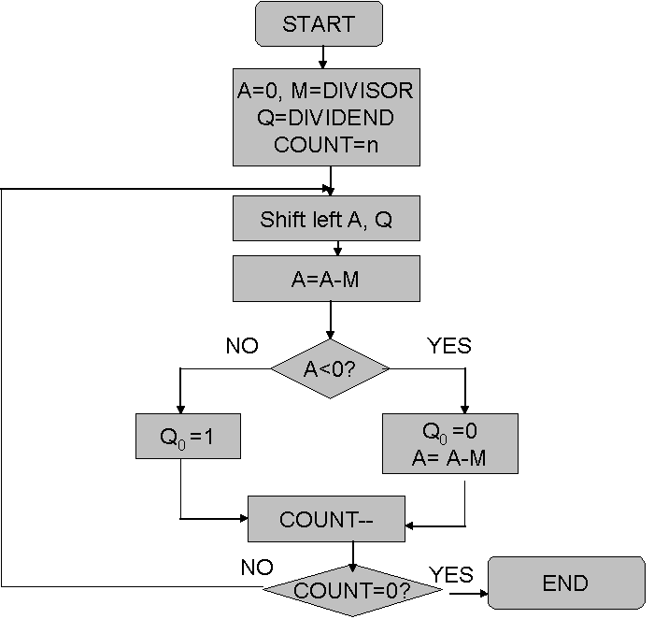

**Design Steps**:

1. Start
2. Initialize A=0, M=Divisor, Q=Dividend and count=n (no of bits)
3. Left shift A, Q
4. If MSB of A and M are same
5. Then A=A-M
6. Else A=A+M
7. If MSB of previous A and present A are same
8. Q0=0 & store present A
9. Else Q0=0 & restore previous A
10. Decrement count.
11. If count=0 go to 11
12. Else go to 3
13. STOP

**Example:- (Handwritten solved problems needs to be uploaded)**

**CODE:**

#include <stdio.h>

#include <stdlib.h>

int dec_bin(int, int []);

int twos(int [], int []);

int left(int [], int []);

int add(int [], int []);

int main()

{

int a, b, m[4]={0,0,0,0}, q[4]={0,0,0,0}, acc[4]={0,0,0,0}, m2[4], i, n=4;

printf("Enter the Dividend: ");

scanf("%d", &a);

printf("Enter the Divisor: ");

scanf("%d", &b);

dec_bin(a, q);

dec_bin(b, m);

twos(m, m2);

printf("\nA\tQ\tComments\n");

for(i=3; i>=0; i--)

{

printf("%d", acc[i]);

}

printf("\t");

for(i=3; i>=0; i--)

{

printf("%d", q[i]);

}

printf("\tStart\n");

while(n>0)

{

left(acc, q);

for(i=3; i>=0; i--)

{

printf("%d", acc[i]);

}

printf("\t");

for(i=3; i>=1; i--)

{

printf("%d", q[i]);

}

printf("_\tLeft Shift A,Q\n");

add(acc, m2);

for(i=3; i>=0; i--)

{

printf("%d", acc[i]);

}

printf("\t");

for(i=3; i>=1; i--)

{

printf("%d", q[i]);

}

printf("_\tA=A-M\n");

if(acc[3]==0)

{

q[0]=1;

for(i=3; i>=0; i--)

{

printf("%d", acc[i]);

}

printf("\t");

for(i=3; i>=0; i--)

{

printf("%d", q[i]);

}

printf("\tQo=1\n");

}

else

{

q[0]=0;

add(acc, m);

for(i=3; i>=0; i--)

{

printf("%d", acc[i]);

}

printf("\t");

for(i=3; i>=0; i--)

{

printf("%d", q[i]);

}

printf("\tQo=0; A=A+M\n");

}

n--;

}

printf("\nQuotient = ");

for(i=3; i>=0; i--)

{

printf("%d", q[i]);

}

printf("\tRemainder = ");

for(i=3; i>=0; i--)

{

printf("%d", acc[i]);

}

printf("\n");

return 0;

}

int dec_bin(int d, int m[])

{

int b=0, i=0;

for(i=0; i<4; i++)

{

m[i]=d%2;

d=d/2;

}

return 0;

}

int twos(int m[], int m2[])

{

int i, m1[4];

for(i=0; i<4; i++)

{

if(m[i]==0)

{

m1[i]=1;

}

else

{

m1[i]=0;

}

}

for(i=0; i<4; i++)

{

m2[i]=m1[i];

}

if(m2[0]==0)

{

m2[0]=1;

}

else

{

m2[0]=0;

if(m2[1]==0)

{

m2[1]=1;

}

else

{

m2[1]=0;

if(m2[2]==0)

{

m2[2]=1;

}

else

{

m2[2]=0;

if(m2[3]==0)

{

m2[3]=1;

}

else

{

m2[3]=0;

}

}

}

}

return 0;

}

int left(int acc[], int q[])

{

int i;

for(i=3; i>0; i--)

{

acc[i]=acc[i-1];

}

acc[0]=q[3];

for(i=3; i>0; i--)

{

q[i]=q[i-1];

}

}

int add(int acc[], int m[])

{

int i, carry=0;

for(i=0; i<4; i++)

{

if(acc[i]+m[i]+carry==0)

{

acc[i]=0;

carry=0;

}

else if(acc[i]+m[i]+carry==1)

{

acc[i]=1;

carry=0;

}

else if(acc[i]+m[i]+carry==2)

{

acc[i]=0;

carry=1;

}

else if(acc[i]+m[i]+carry==3)

{

acc[i]=1;

carry=1;

}

}

return 0;

}

**Conclusion**

The Restoring method of division has been studied and its implementation has been conducted successfully

**Post Lab Descriptive Questions**

1. **What are the advantages of restoring division over non restoring division?**

In each step of your division calculation the result of the step is either 1 or 0, depending on if the dividend is less than or larger than the divisor. You generally do a test subtraction for each digit step; if the result is positive or zero, you note down a 1 as next digit of your quotient. If the result is negative, you proceed with one of two strategies: • restoring method: you add the divisor back and put 0 as your next quotient digit • non-restoring method: you don’t do that - you keep negative remainder and a digit 1, and basically correct things by a supplementary addition afterwards.

**Date: _____________**